MANU2484 – DESIGN FOR ASSEMBLY AND AUTOMATION

PROJECT 1 - DESIGN FOR MANUAL ASSEMBLY

SNAP-FIT BOTTLE CAP

GROUP 1E

Tutorial Session 2

Lecturer: Mr. Jaronie Mohd Jani

Truong Tan Gia Huy – s3806881

Nguyen Bao Tuan – s3713061

Nguyen Mau Tung – s3755518

Dinh Tho Chuong – s3891640

Patrick Mark Kennelly – s4079249

**Submission date:** **21st April, 2024**

**Table of Contents**

PROJECT INTRODUCTION 3

The Project 3

Original Design: 3

Improvements to the Design: 3

Members’ Responsibilities: 3

PROTOTYPE DEVELOPMENT 4

DETAIL OF PROTOTYPE DESIGN 11

CONCLUSIONS 20

REFERENCES 21

# PROJECT INTRODUCTION

This report details the design and development of Group 1E’s snap fit bottle cap in response to the tasked ‘assignment 1’ under the Design for Assembly and Automation (MANU2484) 2024 Autumn course. Here the research and iterative effort undergone to come up with a proposed design is outlined. This report does not report on performance/results.

### The Project

The brief was to design, build, and test a snap-fit bottle cap prototype for a 1.5L carbonated drink bottle (PET). The bottle cap must replace the existing one, utilise a snap fit feature to seal/unseal and must be 3D printed. Once manufactured, the bottle cap will be evaluated against the outlined requirements of sealing, compatibility, material, ease of opening, pouring & dispensing and brand identity & aesthetics. These requirements intend on both quantitatively and qualitatively evaluating the classes produced bottle caps.

### Original Design:

Two initial snap-fit lid prototypes were developed, each featuring annular snap fits to secure the sealing cap component to the new neck base. The first design showcased a hinged cap, while the second featured a 'two-piece' unlinked design. Upon analysis, both models were found to require dimensional improvements to better suit the test bottle.

### Improvements to the Design:

After merging the initial models and identifying tolerance and subsequent distortion issues, the final design is proposed. Enhancing ease of use and pour rate, the inner collar is shrunk, and the spout is elongated. Moreover, increases to the wall thickness aim to mitigate failure rates and prevent permanent deformation. Clearances between the cap and base are refined for smoother assembly/better seal, while grip slots remain on the external interfaces to facilitate ease of use. Additionally, after undergoing reassessment, the threads are improved, and suitability verified.

Figure 1: Snap-fit bottle cap assembly

### Members’ Responsibilities:

* **Truong Tan Gia Huy**: Detail of Prototype Design, Reference, Editing
* **Patrick Kennelly:** Executive Summary, Prototype Development (Threads), Conclusion
* **Nguyen Bao Tuan:** Detail of Prototype Design
* **Nguyen Mau Tung:** Prototype Development, Prototype Model Designing.
* **Dinh Tho Chuong:** Prototype Development (Thread Research)

# PROTOTYPE DEVELOPMENT

#### Description of the design process

**Problem Definition and Research:**

***Potential problem***

**Seal integrity:** A bottle cap's main purpose is to securely close the bottle, stopping leaks and protecting the contents. To keep impurities, air, or moisture out, the cap and bottleneck must create a tight seal.

**Compatibility:** The bottle cap needs to fit into a particular bottle type and size. This is a 1.5 Liter bottle of carbonated beverage. They might, nevertheless, have a variety of bottle neck designs.

**Ease of opening:** Customers should be able to easily open the cap even if it should create a tight seal. Convenience features that guarantee a tight seal include twist-off caps and snap-fit closures. The bottle top in this instance needs to have a snap-fitting mechanism.

**Pouring and dispensing:** The cap must have a feature that makes pouring or dispensing easier without opening the cap, depending on the beverage type and bottle design.

**Brand identity and aesthetics:** Bottle caps frequently enhance the overall appearance of the container and present a branding opportunity. Features that can be customized, such color, form, embossing, or printed logos, can improve brand awareness and attractiveness.

**Material selection:** When it comes to environmental impact, safety, and usefulness, the material chosen for bottle caps is quite important. For testing and demonstration purposes, a 3D printed model will be used in the prototype.

***Research***

The 1.5L carbonated drink bottle (Coca-Cola bottle) must be fitted with the prototype bottle cap, which has a snap-fit design. Researching thread size, material capabilities, user preferences, production feasibility, and a standard bottle cap size were the first steps in the design brainstorming process. This dimension ought to work well with the project design, based on knowledge and study. A standard cap has the following dimensions: base diameter: 31.4 mm, thickness: 0.7 mm, length: 11.6 mm, thread: 2 revolutions, size: M28 x 1.5 ISO Metric. A mass-produce bottle cap's dimensions are shown in the drawing below [1].

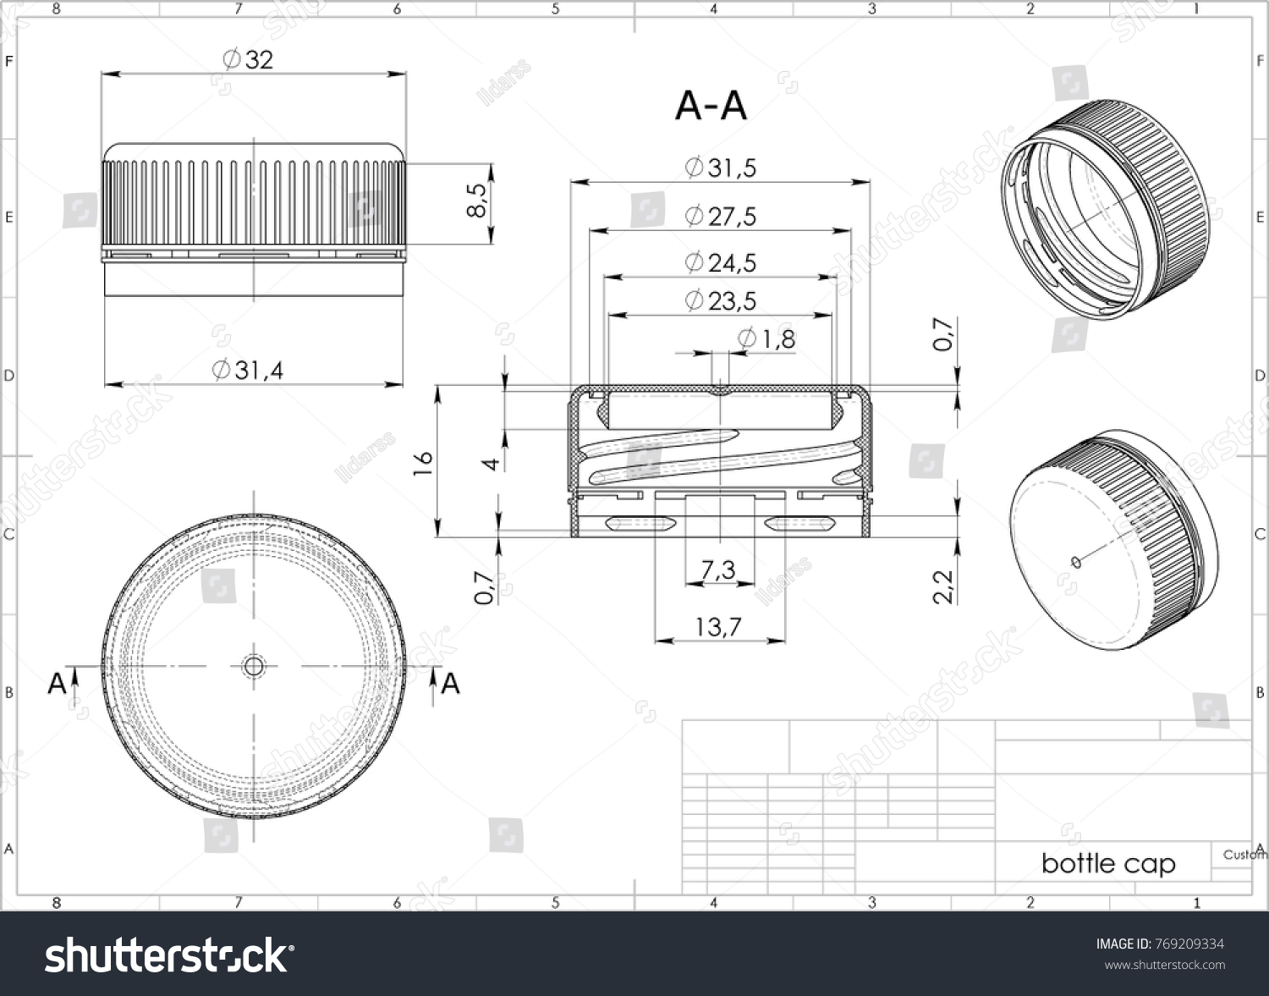

Figure 2: Example bottle cap drawing

The standard bottle cap diameter for a 1.5L carbonate drink bottle is approximately 27.4mm. This is based on the standard thread sizes used for mass produce soda bottles [2,3]:

* PCO1810 (left): Thread diameter is 27.43mm, pitch is 3.18mm.
* PCO1881 (right): Thread diameter is 27.4mm, pitch is 2.7mm.

Figure 3: Image of 2 types of bottle cap, different thread types

**Types of caps:**

* **Screw Caps**: These caps create a durable screw-on seal. A plastic inner liner allows the cap to hold glass or plastic bottle necks and contain fizz. Screw caps can be applied quickly by automated cappers. They allow convenient resealing and are commonly used for soda, carbonated soda water, and beer [4].
  + **Material:** Plastic or Metal, and a wad made from a layer of plastic (often PVDC), cork, rubber.
  + **Advantages:** Resealable, better gas retention, close fit tolerance, quickly applied by automated cappers.
  + **Drawbacks:** Plastic is non-renewable; metal is not resealable.
* **Crown Caps**: Also called pry-off caps, crown seals, or beer caps, these metal caps provide a tight crimped seal ideal for retaining carbonation in glass bottles. Metal cap is difficult to reseal the bottle once open.



These documents above illustrate detail design and dimensions of the two thread sizes.  
 The bottle neck for a bottle using standard measurement called PET bottle neck. It defined by total height, inner diameter and thread. And the dimension express in mm. The finish dimensions’ measurements are including [5]:

**“T” Dimension:** the thread's external diameter. The bottle and closure mate will be determined by the T dimension's tolerance range.

**“E” Dimension:** The thread depth is determined by the neck outside diameter and the division of the difference between the E and T dimensions by two.

**“I” Dimension:** Bottle neck inner diameter. A minimum “I” is required by specification to provide enough room for filling tubes. closures without liners that have a plug or land seal. Furthermore, a regulated "I" dimension is necessary for fittings and dispensing plugs to work properly.

**“S” Dimension:** measured starting at the top of the finish and moving up to the first thread's top edge. It is the crucial element that establishes both the degree of thread contact between the bottle cap and the orientation of the closure to the bottle.

**“H” Dimension:** Height of the neck finish. Measured from the top of the neck to the shoulder intersection where the diameter T extends downward.

For 1.5L bottle, it has the diameter of 94.4mm, height 317mm, neck finish 28mm PCO 1810, Volume 1.5L and weight 43g [6].

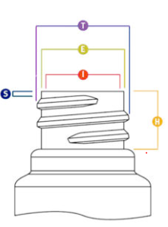

Figure 4: PET Bottle Neck measurement diagram

**Brainstorming and Concept Generation**

Initial thoughts for the lower part of the bottle cap were to duplicate the precise measurements and tolerances from the previously shown standard bottle cap and bottle neck. When the lower part of the replica is sufficiently accurate, the team extends the bottle cap top plane to build the bottle spout and adds a snap-fit cover.

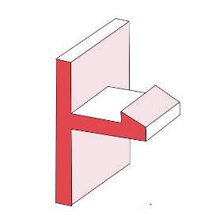 The team came up with the idea of using cantilever type snap-fit locks since they are affordable, dependable, and simple to assemble. It is made out of cantilever beams with tapered or chamfered heads that are flexible and easy to insert [7]. It is possible that these concept ideas for an exterior lock on a bottle cap cover will hold up well.

Figure 5: Cantilever Snap fit

Furthermore, we utilize annular snap-fit joints in our prototype mechanism. Annular snap-fit joints are frequently used in cylindrical parts. They work by engaging with a recess that circles another part by the use of a tiny circular protrusion that is often formed like a ridge. The 45-degree angle slopes of an annular snap-fit joint produce a robust but removable structure [7]. With the ability to flexibly spin the cover, it is the perfect joint for sealing and shutting.

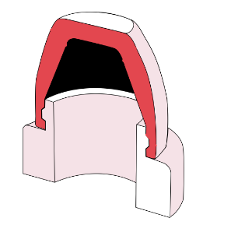

Figure 6: Annular Snap fit

Snap-fit joints are often used in shakers, sport bottles, and other items. They make use of a spout inner collar recess and an inner annular joint on the lid. Additionally, several bottles — like dishwashing liquid, mouthwash, cooking oil, hand gel and so on.— have snap-fit joint bottle closures. These concepts are then refined down to cola bottle cap sizes based on their features, functionalities, and designs. by putting a spout on top of the bottle cap and then including various model-specific components like hinges, snap-fit lid joints, sealing rings and so on.

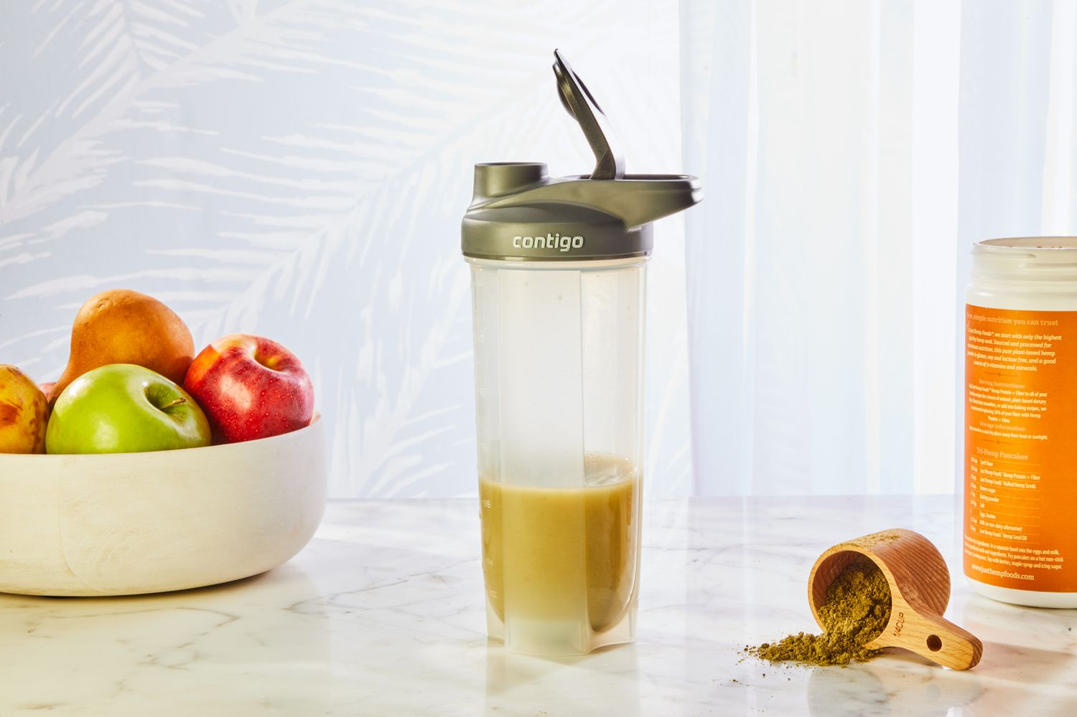

Figure 7: A commercial bottle cap

**Sketching and Initial Prototyping**

Each team member was tasked to try to design their own prototype based on those concept ideas mentioned. After that, there were two model that suitable for the prototype. By far, there were two potential prototypes that were suitable for project design.

***Model 1: By Student Truong Tan Gia Huy***

Figure 8: Prototype No.1

The initial prototype had hinges for the lid, a cantilever snap-fit connection, and two double annular snap-fit joints. Overall, the design is well-thought-out, useful, and leak-proof at the inner joint. Nevertheless, the design of the lid was quite intricate, particularly the inner joint, and the sizes did not correspond to a 1.5L bottle. Overly lengthy cantilever hinges run the risk of breaking during assembly. It also lacks the lower half of the bottle's inner collar sealing ring, which stops leaks into the thread.

***Model 2: By Student Nguyen Mau Tung***

Figure 9: Prototype No.2

The second prototype has a counter hole in the spout so that the lid extrusion to fit perfectly into the bottle cap spout, smaller spout inner collar for reducing water stress during pouring. It also has a single annular snap-fit joint and a smaller spout inner collar. Waterproofing is done via the counter bore. This particular model is composed of two distinct parts: the lid and the cap, which are not connected. Nevertheless, the design includes some time-consuming superfluous elements and loose tolerance.

Figure 10: Prototype No.2 snap fit lid

As the second prototype is a two-piece device, its second component is an annular snap-fit cover. It has a counter bore extrusion to firmly close and seal the spout, preventing leaks, and an annular snap-fit joint recess to suit the cap joint. To begin with, the design is top notch for effortless manipulation while attaching or removing the lid from the spout. Unfit dimension and loose tolerance were the main issues.

# DETAIL OF PROTOTYPE DESIGN

#### Build and Operation Instructions

Both of the early prototypes share the same characteristics, design, and issue with the high annular snap-fit joint position in both models. When the cap walls make contact with the joint, this can result in significant resistance and friction. It also has the potential to distort over time during assembly or disassembly. Additionally, the thread sizes are all different. This is because different bottle caps have different designs, making it challenging to determine a bottle thread size. Both models do, however, still offer some useful, reusable elements. Thus, we combined the lower half of the first prototype with the upper half of the second prototype, shrinking the inner collar of the lower half, changing the thread size, lengthening the spout, thickening the wall, and moving the joints to a lower location in the new model. Resulting the finalized design for project prototype model for the team.

Figure 11: Finalized design for bottle cap and snap-fit lid

Figure 12: Bottle cap is fully assembled

Figure 13: Section view of the full assembled bottle cap

From the cross section view, it can be seen that the two parts fit perfectly together without any gaps. In real life, the snap-fit cap above could deform to fit the lower cap, in some case, printing model will have some excessed part after printed. If there is any interference or difficulty occurred during assembly, the snap fit recess could be trimmed thinner using file tools for easier connection.

The ring around the neck of the spout on the upper part of the cap is the only snap fit detail of the cap, serves as the main feature to prevent the water from leaking out and secure tightly the cover. Moreover, the circular neck underneath the surface of the lower cap fits with the inner collar of a typical carbonated drink bottle neck to preserves the content and preventing leakage and direct the water flow smoothly into the spout inner collar without spilling outside. This is indicated by the red line in the figure below:

Figure 14: Fully assembled bottle cap neck indication

This bottle cap is snap-fit style, therefore, the users only need push and pull action in order to open and close the bottle. All the grooves around the caps are to provide more friction, creating better grip when interacting with them. The two figures below will show the specific drawings of the bottle cap and its snap-fit lid:

Figure 15: Detail drawing of the cap

Figure 16: Detail drawing of Snap-fit cap

All dimensions of the snap-fit cap, especially the annular recess are carefully designed to perfectly fit the bottle cap when assembled. Material tolerance during 3D printing process is also considered when designing the cap.

The table below will list these basic dimensions and thread size.

Table 1: Details dimensions of the cap and snap fit lid

|  |  |  |  |
| --- | --- | --- | --- |
|  | **Manufacture process** | **Quantity** | **Dimension** |
|  | 3d Print | 1 | Lower half Inner collar: 28mm  Lower half outer collar: 30mm  Wall thickness: 1mm  Lower half length: 11.60mm.  Thread size: SP410–M-8  Spout outer collar: 15mm  Spout counter bore: 11mm.  Spout hole: 6mm.  Annular joint size: 1mm, 45 deg. |
|  | 3d Print | 1 | Inner collar: 15.06mm.  Wall thickness 1.5mm.  Annular joint recess: 1.04mm, 45 deg.  Counter bore extrude part: 11.02mm. |

#### Bill of Materials

The models’ volume can be acquired in Mass Properties function in Solidworks software.

Prototype Cap:



3085.85 = 0.0031 litters

Snap-fit Cap:



1325.45 = 0.0013 litters

Based on Dynamism platform [8], a litter of Tough 2000 Resin used for 3D print costs $199.

Therefore: Prototype cap cost = 0.0031*199 = 0.6169$

Snap-fit cap cost = 0.0013*199 = 0.2587$

Table 2: Bill of Materials for bottle cap

|  |  |  |  |  |
| --- | --- | --- | --- | --- |
| **Part Name** | **Manufacture Process** | **Material** | **Quantity** | **Estimated Cost** |
| **Prototype Cap** | 3D Print | Tough 2000 Resin | 1 | 0.6169$ |
| **Snap-fit Cap** | 3D Print | Tough 2000 Resin | 1 | 0.2587$ |
| **Total Cost** | $0.8756 | | | |

#### Analysis

In order to successfully mate the two parts of the snap-fit bottle cap, the assembly operator has to overcome the deflection force and friction force. Below is the theoretical mating force to assemble the annular snap joint with the groove at the end of the Snap-fit cap.

Material properties:

Ultimate Tensile Strength = 46 MPa

Tensile Modulus = 2.2 GPa [9]

Tough 2000 resin has similar properties as ABS plastics [9]. And both mating parts have equal stiffness.

Dimensions:

Undercut (y) = 0.4mm/2 = 0.2mm

Diameter at the joint (d) = 15.06mm

Secant modulus for ABS (Es) = 2400MPa [10]

= = 1.1979

* Geometric factor for rigid shaft, elastic hub (X) = 0.0267 [10]

Friction coefficient ABS () = 0.69

Figure 17: Friction coefficient table [10]

The lead and return angle is 45 degrees. The edge is round so the effective angle = 30 degrees [10]

* Calculate the mating force.

Occurring strain: = * 100% = 0.0133%

* The strain is acceptable compared to the maximum permissible strain value for ABS in lecture slide (0.0133% < 4%).

Figure 18: Maximum permissible strain values of common engineering plastics

Deflection force: P = y * d * Es * X = 0.2 * 15.06 * 2400 * 0.0267 = 193 N

Mating force: W = P * = 193 * = 406.56 N

The mating force needed to assemble two snap-fit parts is 406.56N which is a tremendous force. However, the calculated mating force is only true when the machines assemble the parts in perfectly axial alignment. In reality, the manual assembly will mate the parts at an angle and the mating force needed in this case is much smaller [10].

* Stress analysis.

The snap-fit bottle cap parts are printed layer-by-layer in a process called Fused Filament Fabrication. The printed parts from the FFF process have the strongest tensile loading along the layers and weakest across the layers, due to delamination between layers. Since all loads applied on the bottle cap are in tension, the parts are designed to have the printed layers along the vector path of the tensile stress. This will result in the printed parts’s peak loading performance being 100% as strong as homogenous plastic when the part’s infill density is 100%.

Figure 19: Strength vs Part Density chart

The material assigned for the Solidworks Simulation is ABS PC, because Tough 2000 resin and ABS PC have similar ultimate tensile strength and tensile modulus. From the stress analysis results below, the maximum stress when mating two parts is 22.2MPa, located at the snap-fit cap upper corner. This maximum stress is lower than Tough 2000 resin’s ultimate tensile strength (22.2MPa < 46 MPa) which means the parts will not break during the assembly process.

Figure 20: Simulation result runs in Solidworks

# CONCLUSIONS

This report detailed the ‘design’ stage of the snap-fit bottle cap project tasked in assignment 1 of MANU2484. Group 1E proposed a solution that intends to address the criteria of sealing efficiency, compatibility, material quality, user-friendliness, and brand identity. These criteria form the objectives of the project, of which our team aims to address holistically.

**Expected Outcomes**

*Sealing:*

It is expected that the design will produce an effective seal that will pass both sealing tests 1 and 2. This should equate to a moderately durable product that can contain liquid when tipped upside down and when knocked over. The seal will not be as effective as a standard bottle cap as the snap fit function increases the possibility of failure/knocking the lid off.

*Compatibility:*

The bottle cap design should be compatible with standard 1.5L carbonated drink bottles (PET).

*Material:*

The cap design shall be printed using the RMIT Manufacturing Lab facilities. It is expected that the print quality will be high and the accuracy acceptable.

*Ease of Opening:*

The cap incorporates grip slots to improve users’ ability to grab and open the lid. There is uncertainty surrounding the force required to open and shut the lid but it is expected to be acceptable.

*Pouring and Dispensing:*

The design may exhibit lower performance in this category during testing. The pour rate test aims to achieve the quickest dispensing rate possible. However, our design prioritises user comfort and ergonomics, resulting in a smaller spout size that may impact flow rate.

**Future Direction**

The team will now move to the build stage of the project. Looking to print the designed cap to the best quality achievable utilising the universities facilities. Finally, our product, along with the classes, will be tested and evaluated. Here we will learn whether our expected outcomes are achieved, why or why not and what needs to be improved in future iterations.

# REFERENCES

[1] Ildarss, “3D illustration bottle cap above engineering stock illustration 769209334,” Shutterstock, https://www.shutterstock.com/image-illustration/3d-illustration-bottle-cap-above-engineering-769209334 (accessed Apr. 20, 2024).

[2] “Soft drink bottle top thread sizes (08/05/12),” Imajeenyus, http://imajeenyus.com/mechanical/20120508_bottle_top_threads/index.shtml (accessed Apr. 20, 2024).

[3] “What is the thread size on a soda bottle? understanding soda bottle thread standards,” Dmcoffee.blog, https://dmcoffee.blog/what-is-the-thread-size-on-a-soda-bottle/ (accessed Apr. 20, 2024).

[4] “The ultimate carbonated beverage filling machine,” iBottling, https://ibottling.com/carbonated-beverages-filling-machine-ibottling/ (accessed Apr. 20, 2024).

[5] “Pet bottle neck finish dimensions & pet bottle neck types,” Alleycho , https://alleycho.com/pet-bottle-neck-finish-dimensions-pet-bottle-neck-types/ (accessed Apr. 20, 2024).

[6] “1.5L Soda Bottle - 28mm PCO 1810,” Petainer, https://www.petainer.com/pet-plastic-bottles/soda-bottles/15l-soda-bottle-28mm-pco-1810/ (accessed Apr. 20, 2024).

[7] G. Leo, “Snap Fit Design: Types of Snap fits and Best Practices,” Aria, https://www.madearia.com/blog/snap-fit-design/ (accessed Apr. 20, 2024).

[8] “Formlabs tough 2000 resin 1L,” Dynamism, https://www.dynamism.com/formlabs/formlabs-resin-tough2000.html#:~:text=Tough%202000%20Resin%20is%20the,Tank%20LT%20for%20Form%202 (accessed Apr. 20, 2024).

[9] “Tough 2000 resin,” Formlabs, https://dental.formlabs.com/store/materials/tough-2000-resin/ (accessed Apr. 20, 2024).

[10] “Snap-fit Joints for Plastics,” MIT Fab Lab, https://fab.cba.mit.edu/classes/S62.12/people/vernelle.noel/Plastic_Snap_fit_design.pdf (accessed Apr. 20, 2024).